CSE 211 Web Programming, Fall Semester 24/25

Assignment #1: Websites conceptual Design and mock-up

222101175, Farida Mohamed Adel

**Core Idea**

The assignment aims to practice web designing and how to plan.

**Part 1: research**

**Characteristics from Web 2.0 to Web 4.0:**

**Web 2.0**

User Interactivity and participation.

The change from static web pages (Web 1.0) to dynamic content that allows users to interact, contribute, and collaborate.

Community and social networking drive much of the web experience.

**Web 3.0:**

Data-driven, machine-readable web with a focus on meaning and semantic connections between information.

Emphasis on decentralization and personalized experiences, where AI plays an important role.

**Web 4.0:**

A symbiotic relationship between humans and machines, where AI-driven systems become more autonomous and integrated into daily life.

The web has become ubiquitous and intelligent.

**Key features of web 2.0 and how it empowers the power of networks:**

* Social Media Platforms
* APIs for Integration

Enabling people to make and post contents such as what is given in the social media platforms, which link more users.

Facilitating cooperative work online, so those who need to share and work together may do so successfully.

**Key features of web 3.0 and how it empowers the meaning of data and knowledge connections:**

* Semantic Web Technologies
* Artificial Intelligence

Making data understandable to machines so they can link and process information more intelligently (example: AI predicting what you need).

Linking data from multiple sources to generate enhanced, targeted, and relevant experiences for users of the web.

**Key features of web 4.0 and how it empowers the intelligence connections:**

* Web of Things (WoT)
* AI and Autonomous Systems

Applying embedded smart systems that can make and execute decisions independently with less or no human control.

Integrating smart devices or even smart homes & smart cities to respond actively and collectively in real-time.

**The importance of collective intelligence, social networking, social media and social bookmarking:**

Group decision making is the aggregation of different ideas or opinions to arrive at a solution regarding a particular problem or idea and establishment of relation between individuals who want to exchange information and or support. Social media brings out the ability for people and organizations to share with large communities, and social bookmarking simply sets out to make useful sources more accessible and known.

**How these technologies empower the current and future business plans:**

In this case, Web 2.0 transformation to Web 4.0 aids businesses to work smarter and not harder. Web 2.0 is all about group work and customer relations at social networks; Web 3.0 utilizes data and artificial intelligence to predict the customer and help make efficient decisions. In Web 4.0 smart devices and automation enhance the activities of businesses to enable them notice changes and seize new opportunities. Altogether, the mentioned innovations enable reaching customers, improving operations, and expanding in a digital environment.

**How do I intend to use the latest technologies in my profession:**

I could use the virtual meetings to help me work in international based companies where I can do my work remotely. Also I could use some help from Ai to analyze and predict data. Finally, I could use these technologies in my website so that it can be more interactive to users and easy to deal with.

**Part 2: website planning**

1. **The purpose of the website:**

The purpose of the website is to provide an online platform for book lovers to discover, purchase, and read a wide variety of books. The website aims to create an accessible and enjoyable shopping experience for readers.

1. **What would I like the website to accomplish:**

I want the website to become a go-to destination for readers looking for new books and special offers.

1. **The intended audience:**

The intended audience includes avid readers, students, parents looking for children's books, and anyone interested in exploring new literature without the need for physical storage.

1. **Opportunities, problems, or issues does my planned website address:**

The website addresses the problem of limited physical space for storing books and the challenge of finding specific titles in traditional bookstores. It provides an opportunity for readers to access a wide range of books conveniently and at competitive prices.

1. **Content could be incorporated on my website:**

The website could feature book listings, reviews and reading lists.

1. **How will the site serve the client:**

The site will serve the client by offering an easy-to-use interface for browsing, searching, and purchasing books.

1. **What's the best method for the user to do what's wanted:**

Users can easily navigate the website using categories and search functionality to find books that match their interests.

1. **How will users find the function:**

Users will find the function through well-organized menus, search fields and popular and new publications sections.

1. **How will the results of the function be received:**

Users will receive results in the form of a list of book titles, along with descriptions, prices, and purchase options.

1. **What will the receiver do with the received entries:**

Users can review the book information, add desired items to their shopping cart, and proceed to checkout to complete their purchase

1. **How will the receiver deal with results:**

The receiver will process the order, manage inventory, and handle payment transactions through secure methods.

1. **The follow-up that will be needed:**

Follow-up will include sending order confirmation emails, providing tracking information, and encouraging users to leave reviews or ratings for their purchases.

1. **Related sites found on the web:**

* Bookworm egypt
* eBooks

I chose these two sites because they’re simple in design and easy to use.**Planning Analysis Sheet**

### **Website Goal**

### The goal of this website is to provide a user-friendly online bookstore where visitors can browse, purchase, and review books. The website will offer a wide range of genres and titles, along with recommendations and special offers to make the book-buying experience enjoyable and seamless.

### **List of Working Titles for Pages**

New Collection

Category

Contact Us

About Us

Search

Shopping Cart

1. **Description of Page Contents**

### **New Collection**

Description: This page highlights the newest books available in the store. Users can browse recent releases, see book covers, prices, and read short descriptions. There’s also a button to add books to the cart.

Content: New book covers, prices, descriptions, and "Add to Cart" buttons.

### **Category**

Description: The Category page sorts books by genre (like Fiction, Mystery, Romance). Users can choose a genre, view books in that category, and quickly add them to their cart.

Content: List of book genres, book covers, short descriptions, and filters to browse by category.

### **Contact Us**

Description: This page allows users to get in touch with the store. It has a form where users can enter their name, email, and a message. There are also contact details like phone numbers and business hours.

Content: Contact form, customer service details, and business hour

### **About Us**

Description: The About Us page tells the story of the store—what it’s about, why it was started, and the people behind it. It explains the mission and values of the bookstore.

Content: Company background, mission statement, and team information.

### **Search**

### Description: Users can search for specific books by typing in keywords, like the book title or author name. The page will show results with book covers, prices, and descriptions.

Content: Search bar, book search results including covers, prices, and descriptions.

### **Shopping Cart**

Description: This page shows the books that users have added to their cart. Users can see the total price, adjust quantities, remove items, and proceed to checkout to complete their purchase.

Content: List of selected books, total price, quantity adjustments, and checkout button.

### **d. Description of Forms and How Users Will Interact**

**Registration/Sign-In Form**: Users will sign up with their email, create a password, and provide basic profile information. This form will allow users to manage their orders and preferences.

**Order and Shipping Form**: During checkout, users will fill out shipping and payment details. This includes fields for address, payment method, and delivery preferences.

**Survey or Poll**: Occasional polls or surveys can be incorporated to gather feedback on new features or customer satisfaction.

**Part 3: Website Design**

**[A]:**

**1. Law of PRAGNANZ (Simplicity)**

Implementation: The website will have a clean and simple design. Everything will be organized so users can quickly find what they need without confusion.

**2.Closure**

Implementation: Items like book lists will be arranged in neat grids, so users can easily understand that they belong together, even if some borders aren't fully drawn.

**3. Symmetry and Order**

Implementation: Pages like "Contact Us" or book categories will have a balanced, symmetrical layout, making the site look organized and easy to follow.

**4. Figure/Ground**

Implementation: The main content, like book covers and titles, will stand out clearly from the background to help users focus on what's important.

**5. Uniform Connectedness**

Implementation: Related information, like book titles, prices, and "Add to Cart" buttons, will be grouped close together so users can easily see that they belong to the same book.

**6. Common Region**

Implementation: Sections like categories or book collections will be separated by borders or background colors, making it easy to understand what belongs in each section.

**7. Proximity**

Implementation: Information that belongs together, like a book's title, image, and price, will be placed close to each other to show they are related.

**8. Continuation**

Implementation: Elements like menus will be placed in the same spots on every page, so users can easily navigate from one section to another without getting lost.

**9. Common Fate (Synchrony)**

Implementation: Interactive items, like book covers and details that expand together when hovered over, will show they are linked by moving or changing together.

**10. Parallelism**

Implementation: Items arranged in parallel, like rows of book covers, will make it clear that they are part of the same group or category.

**11. Similarity**

Implementation: Items that look the same, like buttons or fonts, will help users understand they are connected or do the same thing, like adding books to the cart.

**12. Past Experience**

Implementation: The site will use familiar elements, like a search bar at the top and a shopping cart icon, making it easy for users who’ve shopped online before.

**[B]:**

**1.Screen Resolution:**

1440,2513

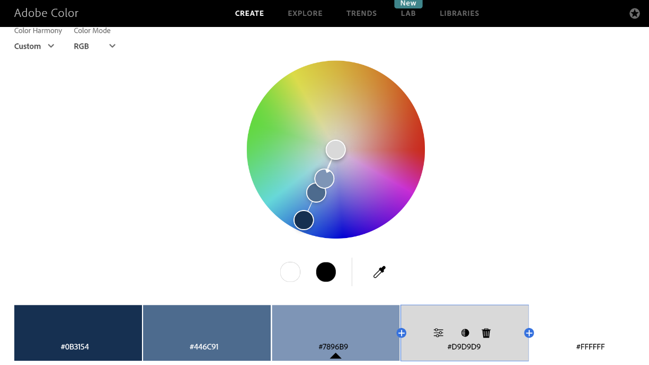**2.Color Palette:**

**3. Minimum Contrast Accessibility:**

**4.Front-end development technologies:**

HTML will be used as the core structure of the website, providing the foundation for all content. CSS will manage the styling and layout to create an appealing design. JavaScript will be added to enable interactive features and enhance user experience on the website.

**5.Content Management Systems (CMS):**

Platforms like Shopify, Wix, and Squarespace are excellent for easy setup, with customizable themes and built-in e-commerce tools.

**6**. **Back-end development technologies:**

PHP will be used to develop dynamic web pages and applications, while Laravel, a PHP framework, will provide flexibility and creativity through its built-in tools, making development more efficient and user-friendly.

**7. Metrics planning to use for measuring website performance:**

I'll use UptimeRobot to keep track of the website’s uptime. If the site goes down, I’ll get an alert right away so I can fix it quickly. This helps make sure the website stays available and reliable for users.

**8. HTML5 Structure:**

<!DOCTYPE *html*>

<html *lang=*"en">

<head>

    <meta *charset=*"UTF-8">

    <meta *name=*"viewport" *content=*"width=device-width, initial-scale=1.0">

    <title>Page Turner</title>

    <link *rel=*"stylesheet" *href=*"styles.css">

</head>

<body>

    <header>

        <h1>Page Turner</h1>

        <nav>

            <ul>

                <li><a *href=*"new.html">New Collection</a></li>

                <li><a *href=*"home.html">Home</a></li>

                <li><a *href=*"shop.html">Shop</a></li>

                <li><a *href=*"contact.html">Contact us</a></li>

                <li><a *href=*"about.html">About Page Turner</a></li>

            </ul>

        </nav>

    </header>

    <main>

        <section>

            <h2>Happy Reading</h2>

        </section>

    </main>

</body>

</html>

**Website Design:**



